# DESIGN ANALYSIS - **CRITERIA TABLE**

Note: we provide an example based on a flyer for a school event just to guide you how to complete this table.

To submit:

1. Individual work. Select 2 or 3 pages on a magazine to analyze.
   * You can select a paper magazine or a web magazine
2. **Insert screenshots of your magazine pages** you have selected regarding this design analysis work.
3. Replace the **last column with your design analysis**.
   * You can write in Khmer or English

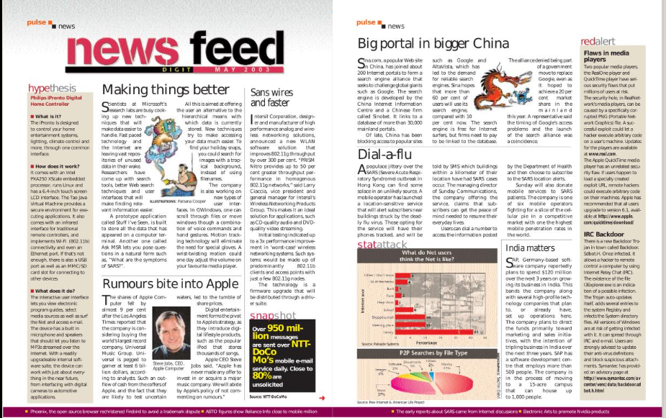

|  |  |  |
| --- | --- | --- |
| CATEGORY | CRITERIA | EXAMPLE OF ANALYSIS |
| **FONT** | The **fonts**, the **font size**, and style are well selected and create a visual **interest** | The design uses a bold and eye-catching font for the event title,and the main point also have bold too,but the main point have diferent font size and the body text uses a small font that is difficult to read .  The font style is consistent throughout the design. |
| **COLOR** | The **color palette** is well selected and create a visual **interest** | The design uses a color scheme that complements the News feed colors and creates visual interest.  Have alot color on Text body. not good. |
| **COMPOSITION** | The layout of the design well-organized and **easy to follow**, with a clear **hierarchy** of information | The layout of the design is well-organized and easy to follow, but have picture between body it make it hard viusal. |
| **CONTRAST** | Is there sufficient **contrast** between the different elements of the design to **make them stand out** and create visual interest | The use of contrast in the design is good. By include big font and bold.  The event title stands out but the body text is difficult to read. And it have a lots group too. |
| **BALANCE** | Is the design **balanced** in terms of its use of space, text, and graphics | The design is well-balanced in terms of its use of space, text, and graphics Include color background. |
| **PROXIMITY** | Are related elements of the design **grouped** together to create **visual unity** and **hierarchy** | The related elements of the design are grouped together effectively, with the event title, date, and location presented in a clear and organized manner.it well |
| **REPETITION** | Is there consistent use of design elements (such as fonts, colors, and graphics) throughout the design to **create visual unity** | The design does not make consistent use of design elements throughout the flyer, which could have helped to create visual unity. But it use only font style.  For example, the use of the background color on the left and the background color could have been repeated throughout the design. |
| **WHITE SPACE** | Is there sufficient white space (or negative space) in the design to create **visual breathing room** and balance | The design makes good use of white space to create visual breathing room and balance.  The use of white space also helps to highlight important information.q |